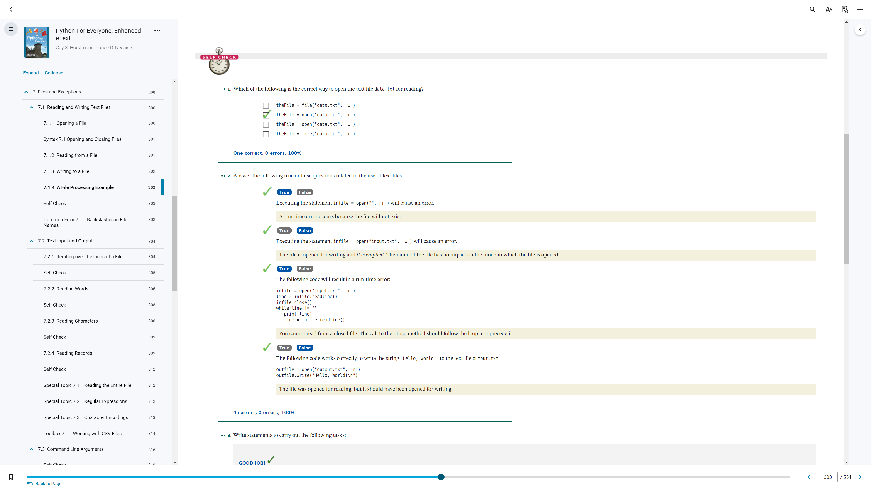

7.1 (p.1)

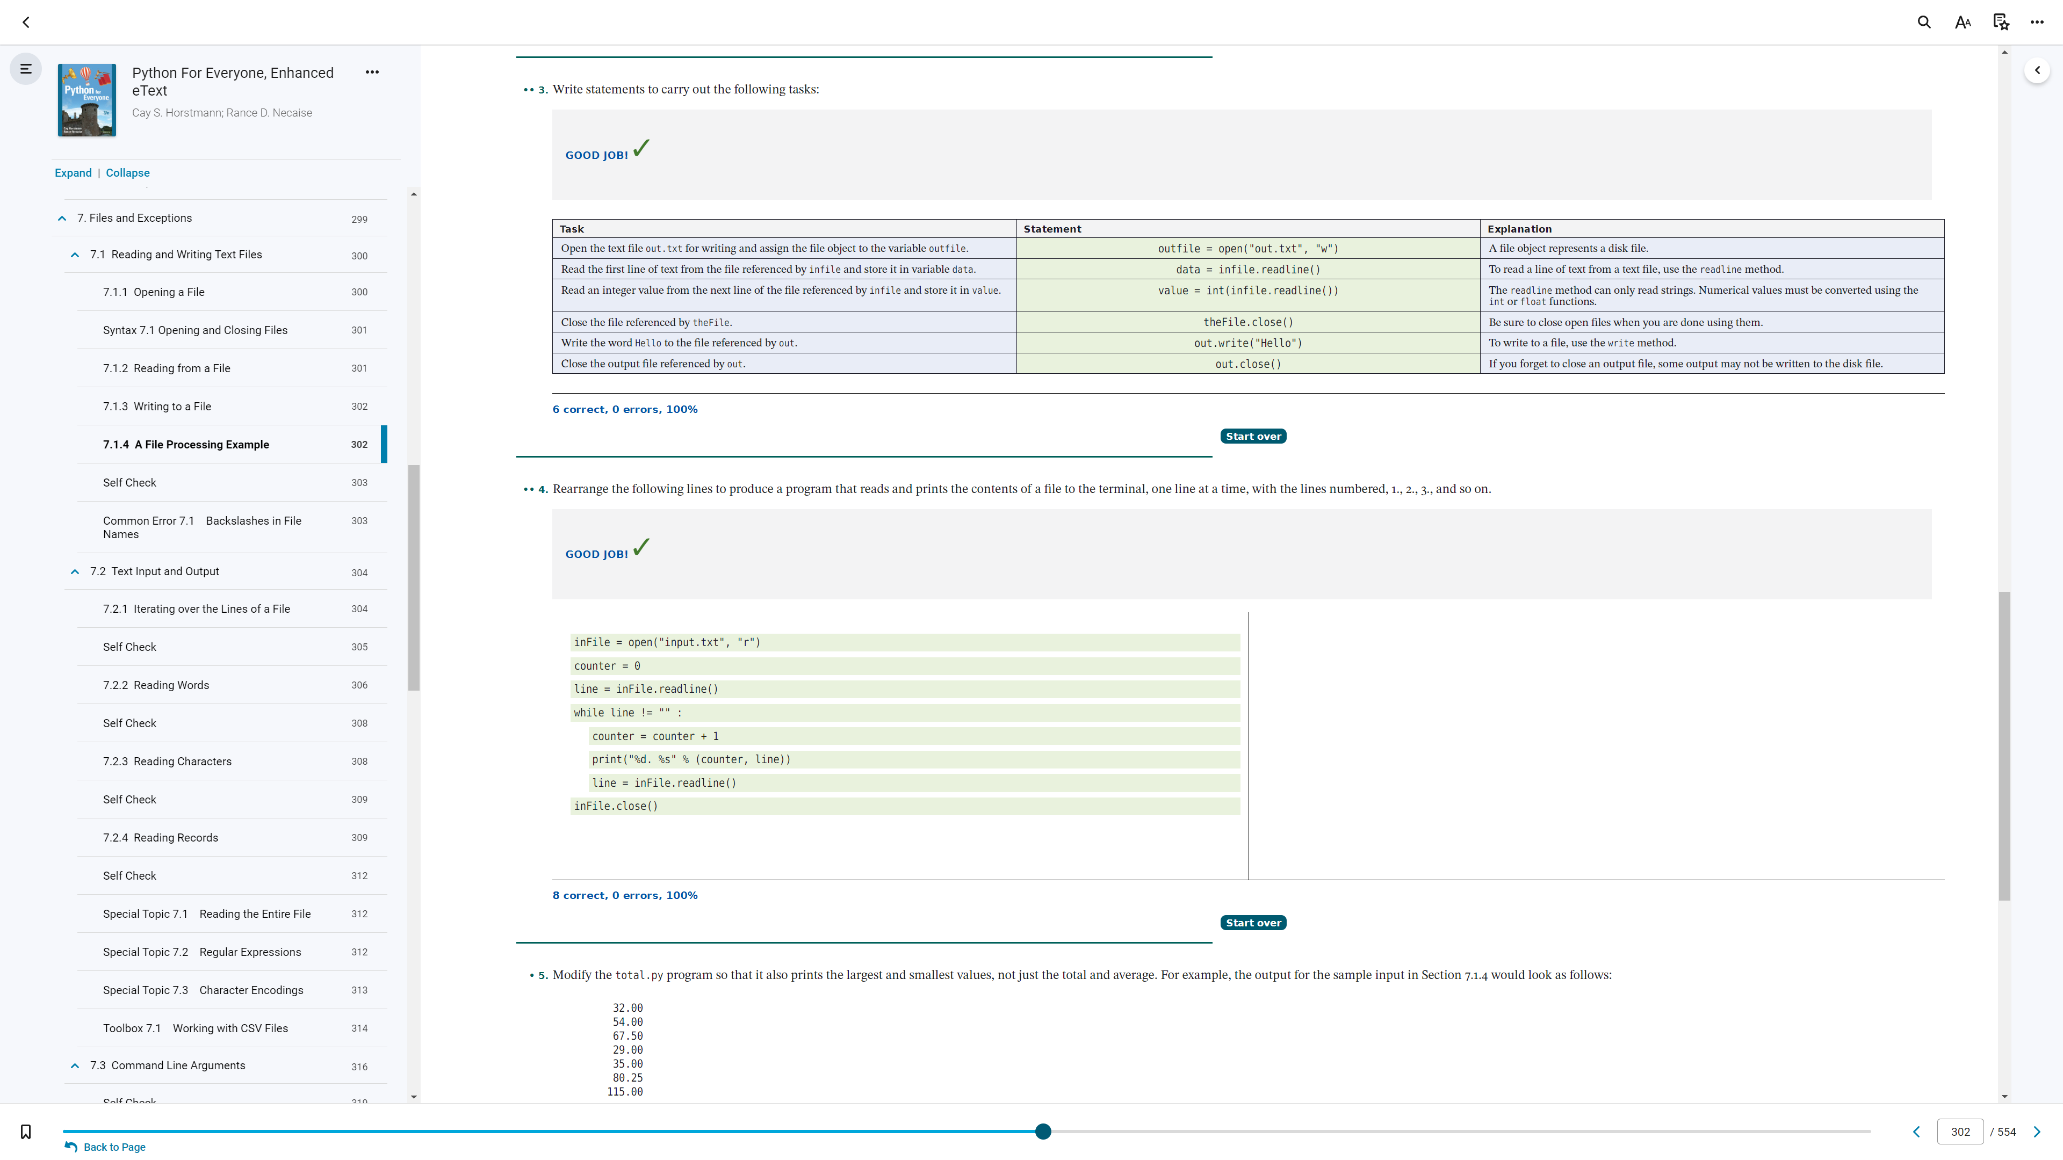

7.1 (p.2)

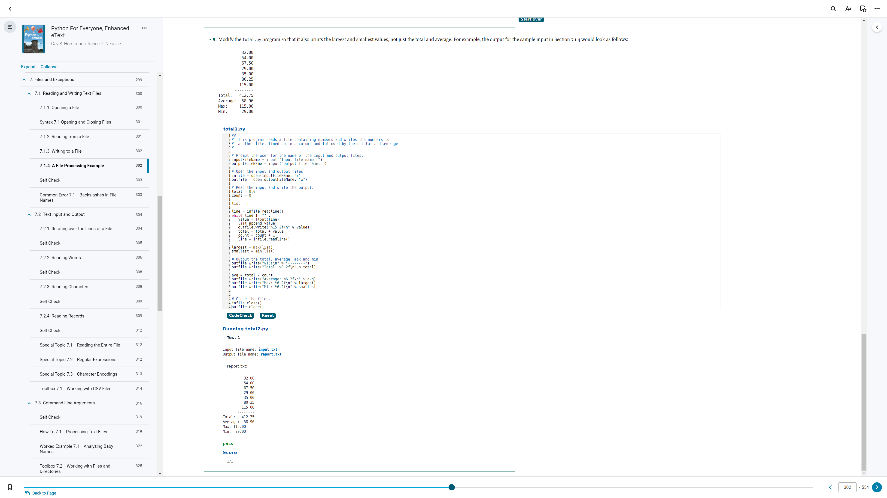

7.1 (p.3)

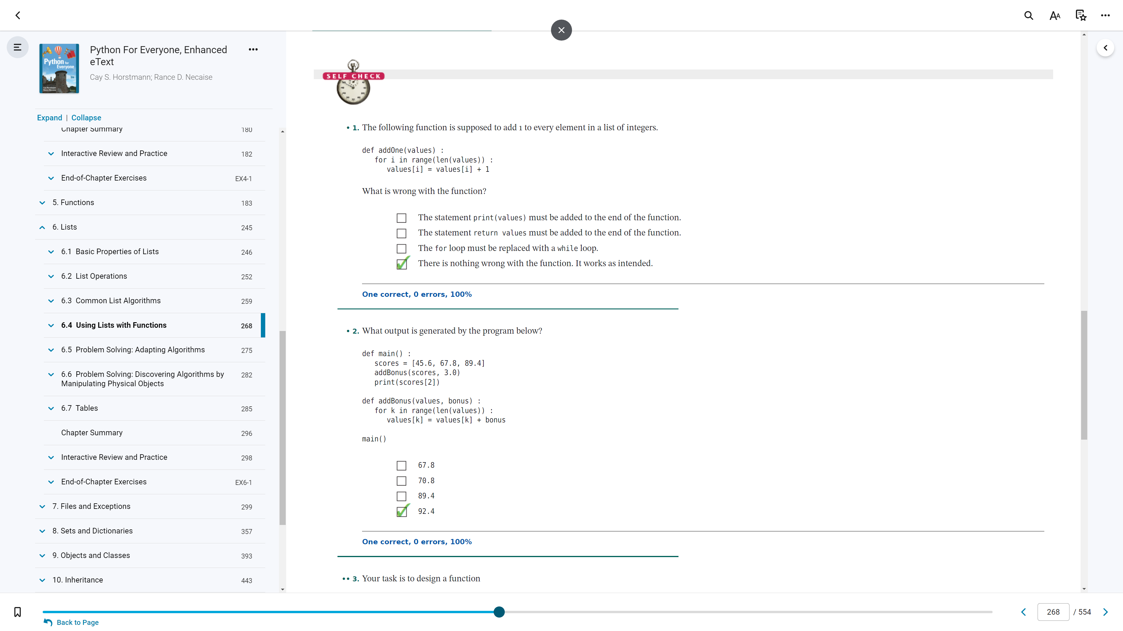

6.4 (p.1)

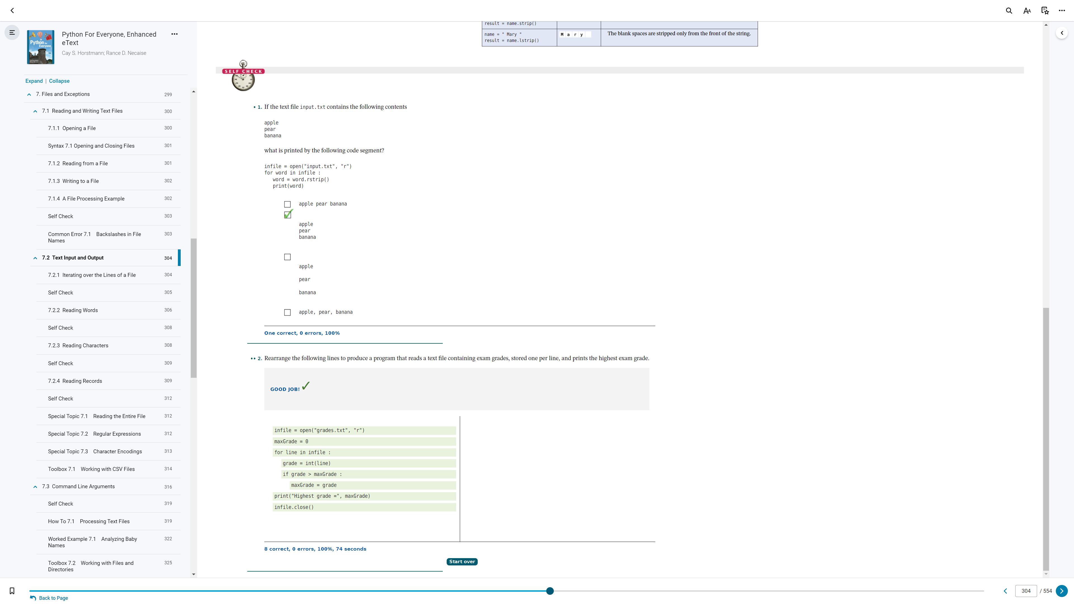

7.2.1

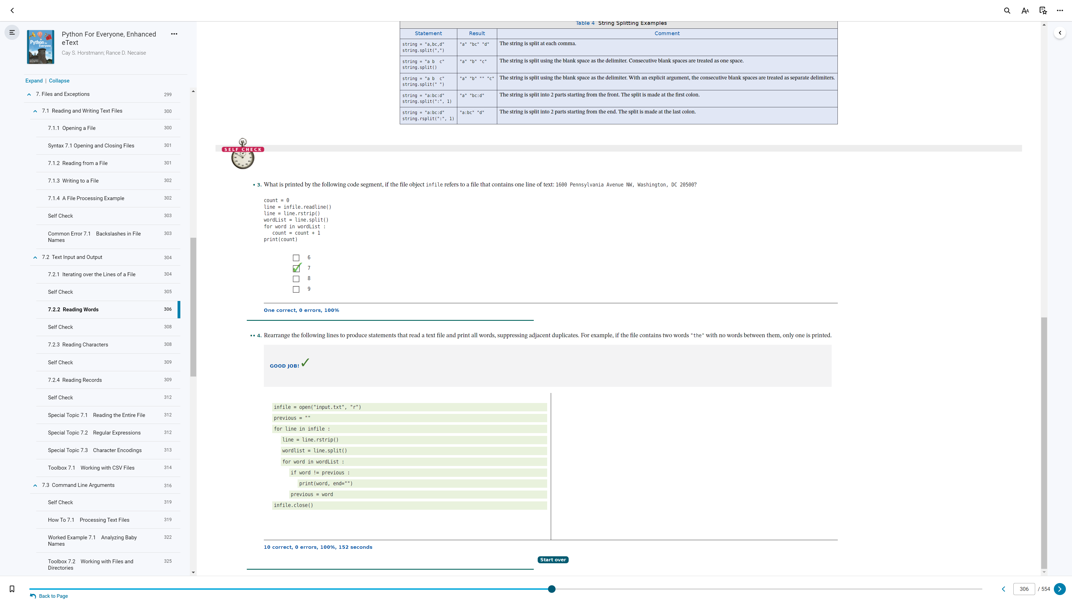

7.2.2

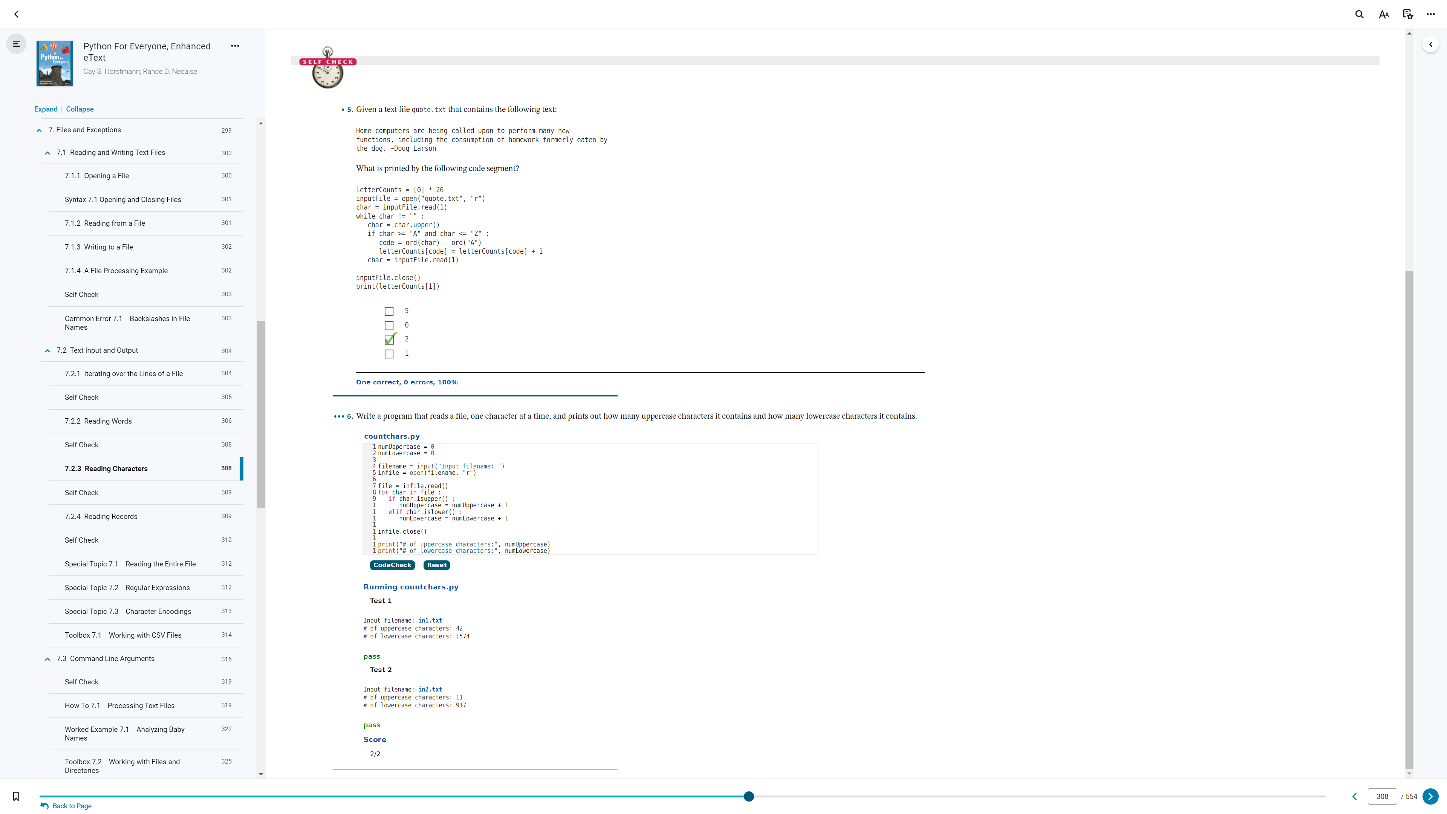

7.2.3

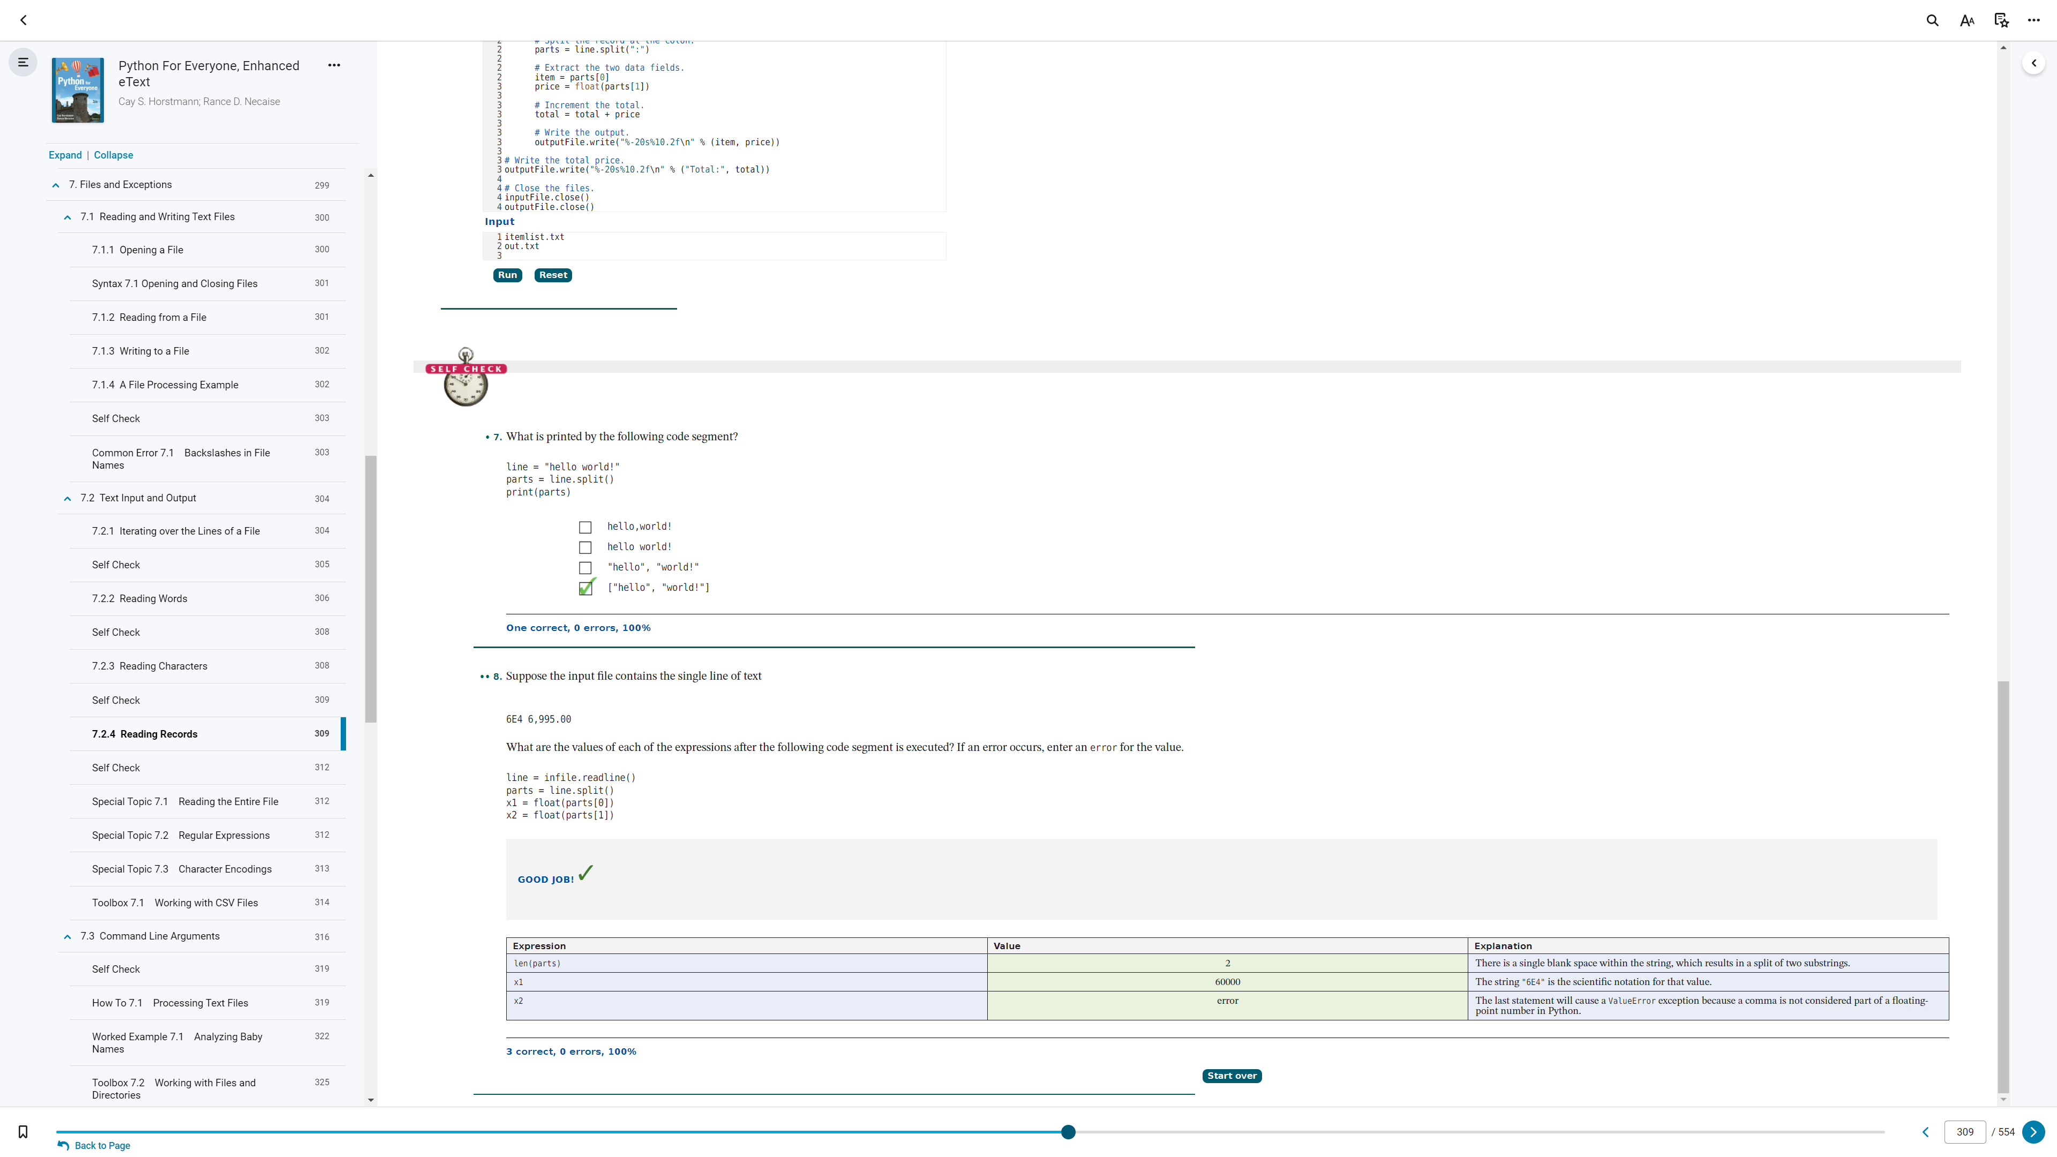

7.2.4

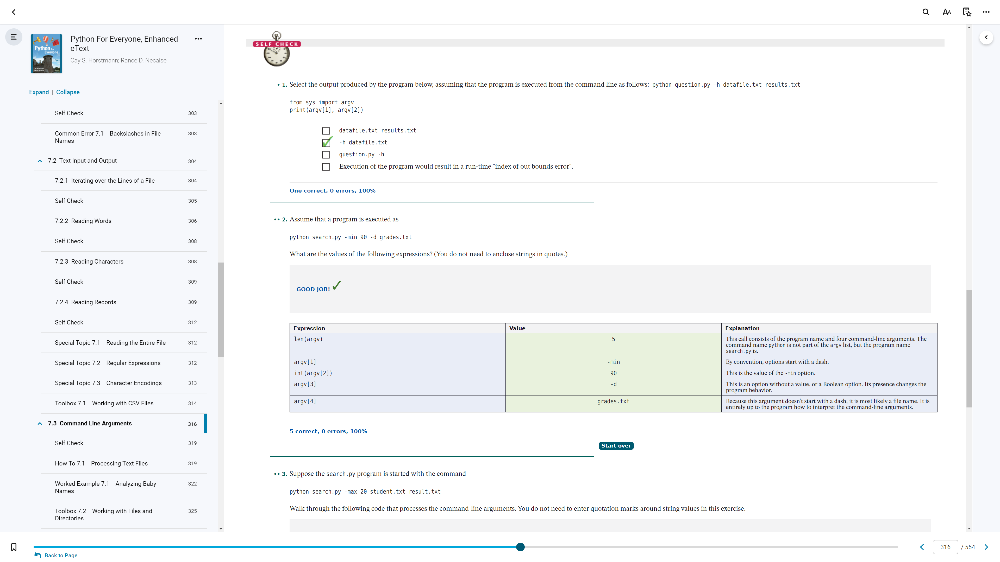

7.3 (p.1)

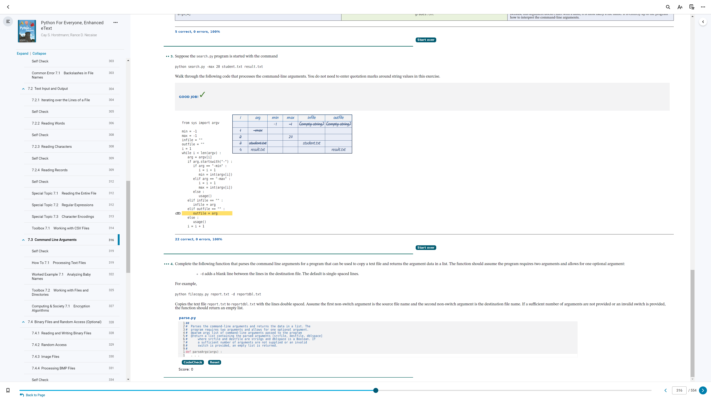

7.3 (p.2)

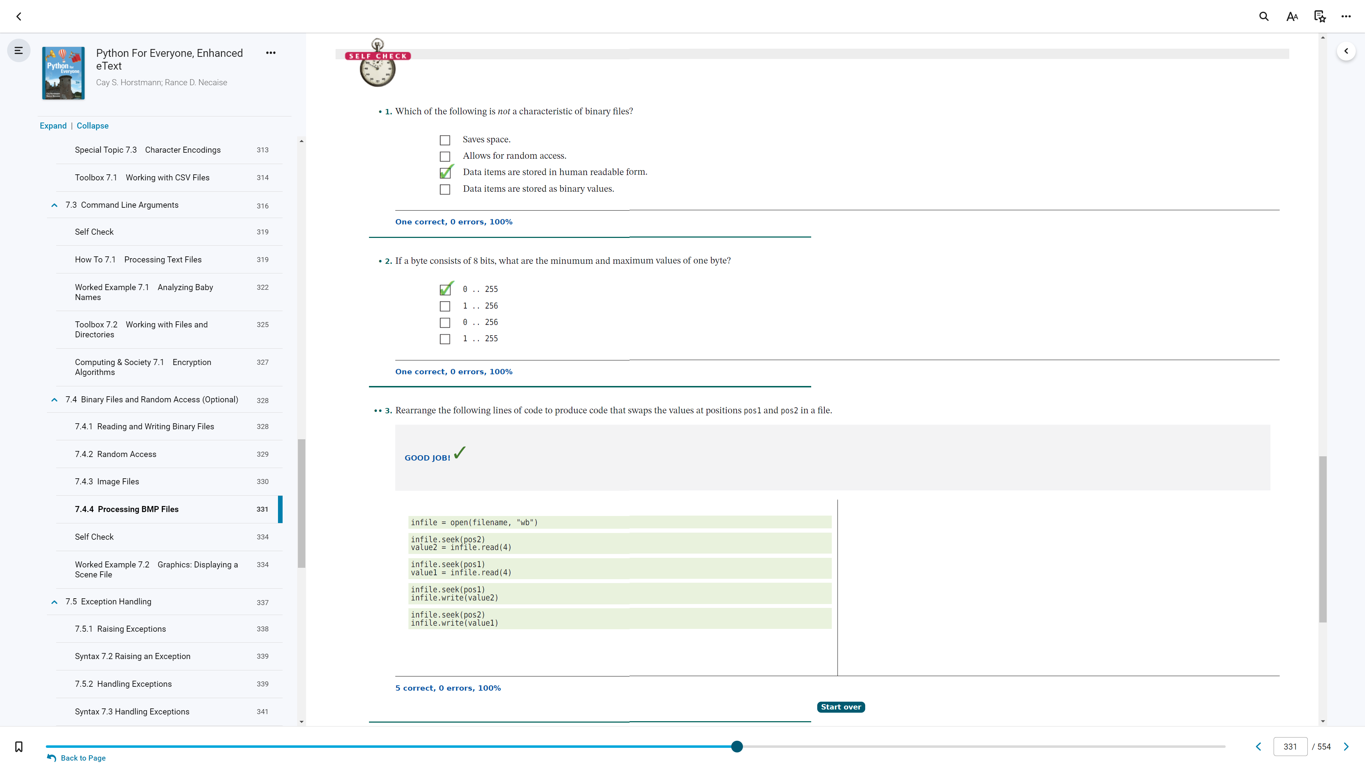

7.4 (p.1)

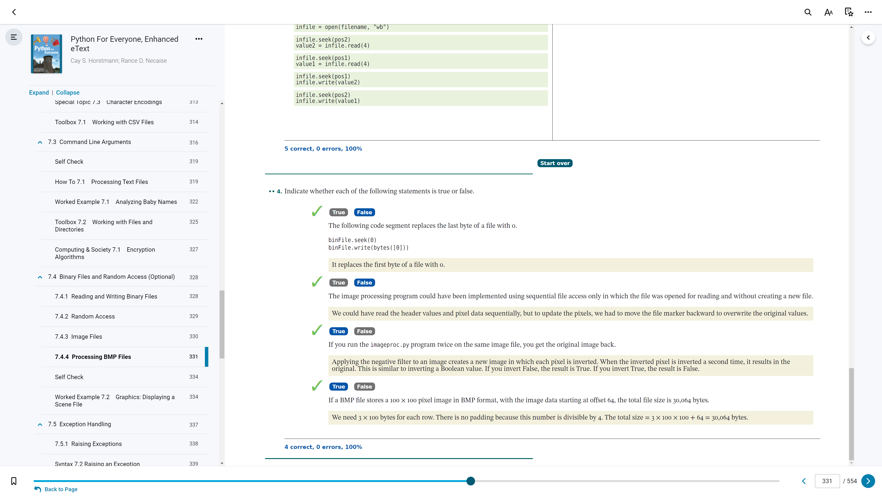

7.4 (p.2)

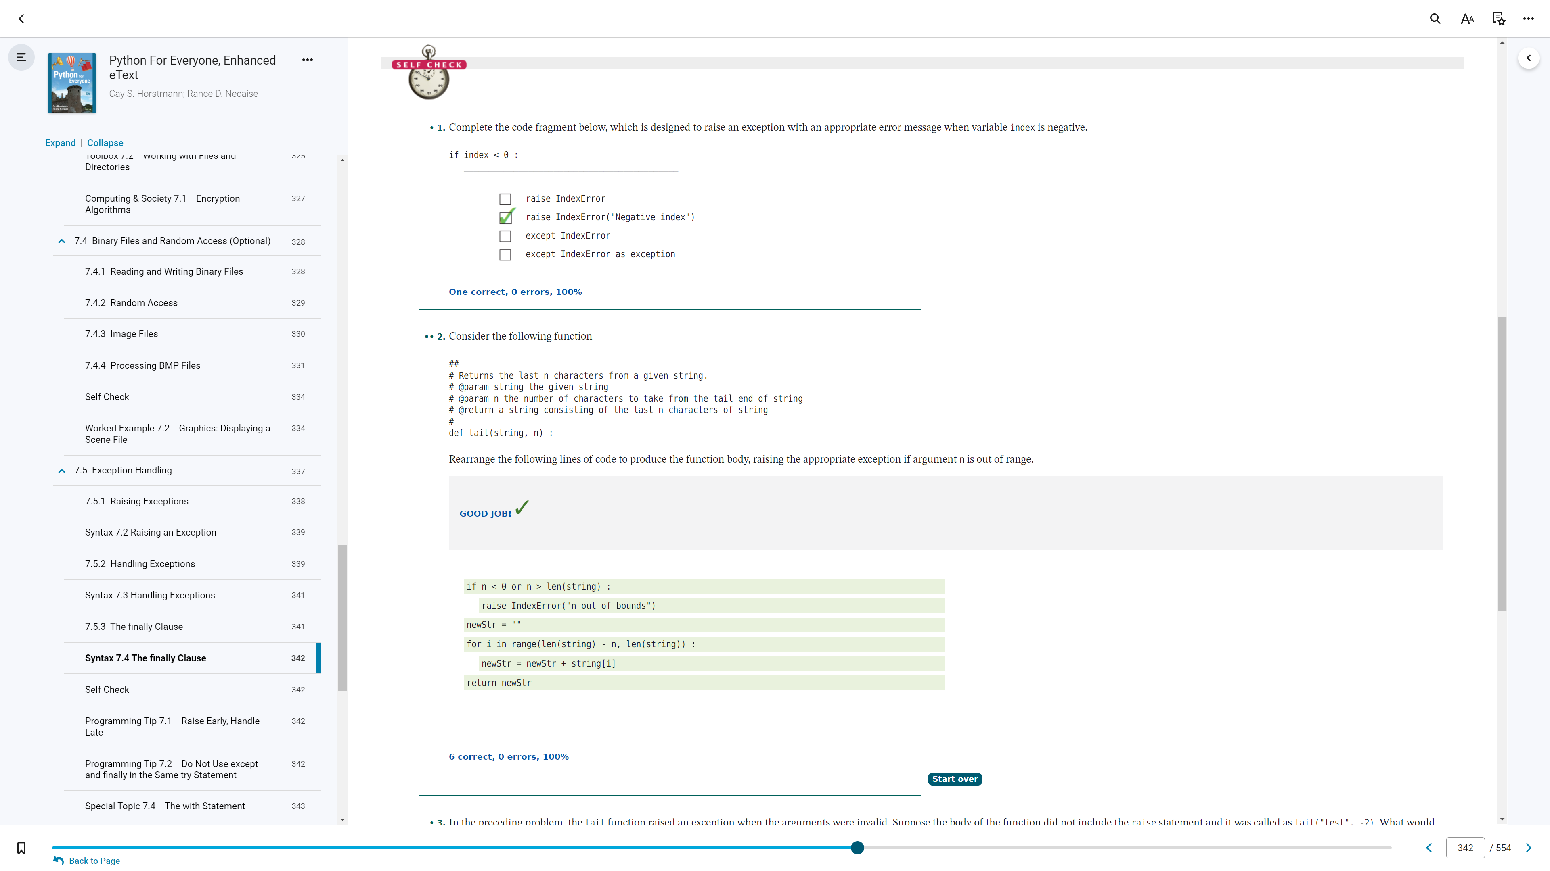

7.5 (p. 1)

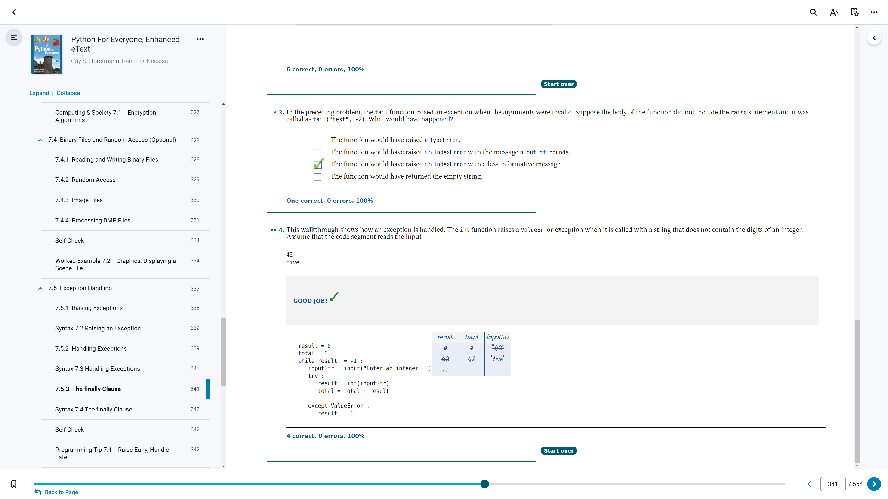

7.5 (p. 2)

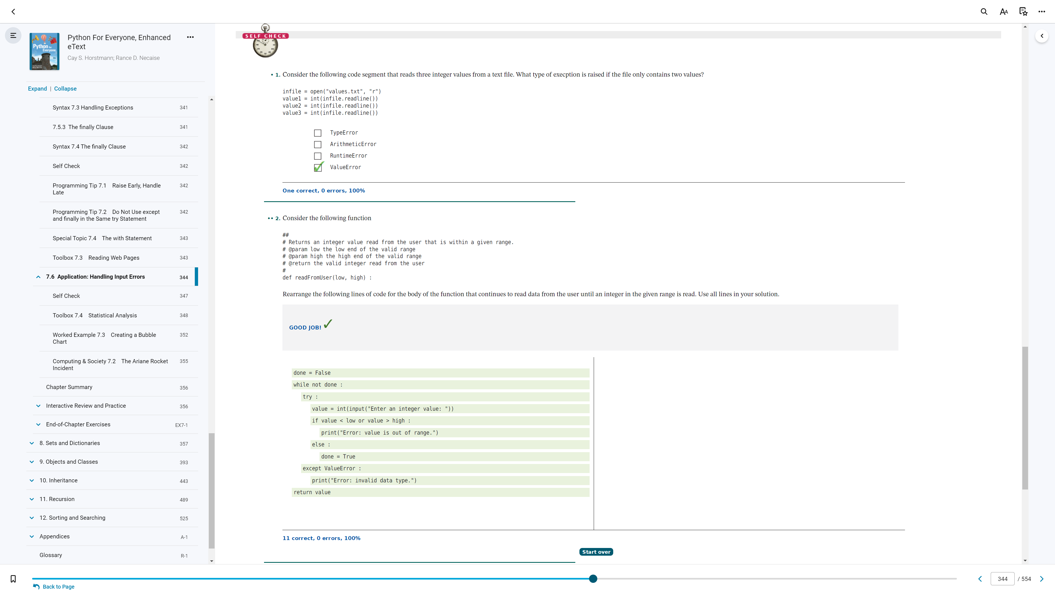

7.6 (p. 1)

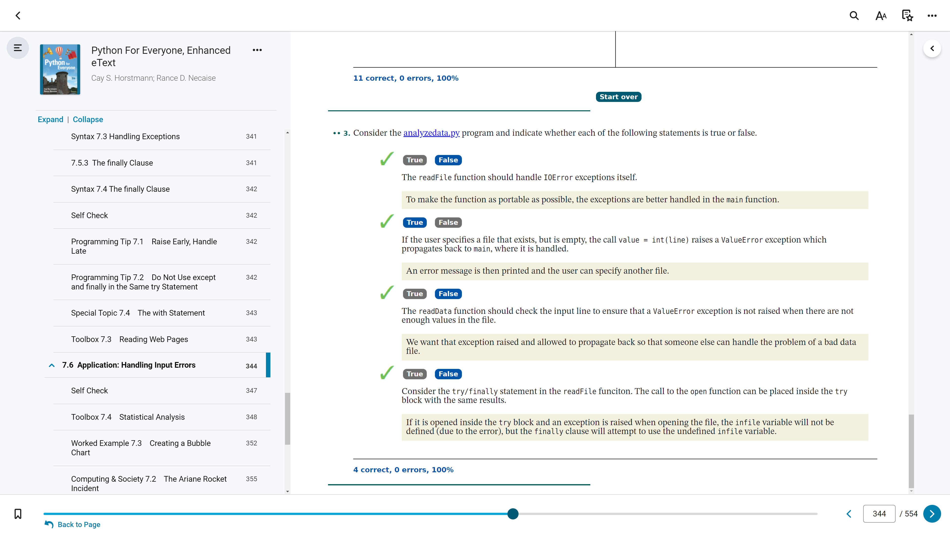

7.6 (p. 2)

7.1 (p.1) - A File Processing Example (1, 2)
7.1 (p.2) - A File Processing Example (3, 4)
7.1 (p.3) - A File Processing Example (5)
6.4 (p.1) - Using Lists with Functions (1, 2)
7.2.1 - Iterating over the Lines of a File (1, 2)
7.2.2 - Reading Words (3, 4)
7.2.3 - Reading Characters (5, 6)
7.2.4 - Reading Records (7. 8)
7.3 (p.1) - Command Line Arguments (1, 2)
7.3 (p.2) - Command Line Arguments (3, 4)
7.4 (p.1) - Processing BMP Files (1, 2, 3)
7.4 (p.2) - Tables (4)
7.5 (p. 1) - Syntax 7.4 The finally Clause (1, 2)
7.5 (p. 2) - Syntax 7.4 The finally Clause (3, 4)
7.6 (p. 1) - Application: Handling Input Errors (1, 2)
7.6 (p. 2) - Application: Handling Input Errors (3)

